**Advance Excel Assignment 5**

1. **How many types of conditions are available in conditional formatting on Excel**

There are 5 are types of conditional formatting in Excel

Highlight Celss rules

Top/Bottom Rules

Data Bars and

Color Scales

Icon sets

2. How to insert border in Excel with Format Cells dialog?

**Draw cell borders**

Click Home > the Borders arrow .

Click the Borders arrow > Line Color arrow, and then pick a color.

Click the Borders arrow > Line Style arrow, and then pick a line style.

Select cells you want to draw borders around.

3.How to Format Numbers as Currency in Excel

To quickly apply the Currency format, select the cell or range of cells that you want to format, and then press Ctrl+Shift+$.

On the **Home** tab, in the **Number** group, click **Accounting Number Format** Accounting number format button. If you want to show a currency symbol other than the default, click the arrow next to the **Accounting Number Format** Accounting number format buttonbutton and then select another currency symbol.

**4. What are the steps to format numbers in Excel with the Percent style?**

On the Home tab, in the Number group, click the icon next to Number to display the Format Cells dialog box. In the Format Cells dialog box, in the Category list, click Percentage. In the Decimal places box, enter the number of decimal places that you want to display.

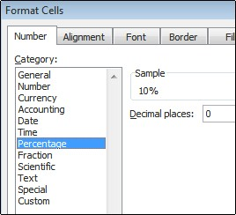

**5. What is a shortcut to merge two or more cells in excel?**

Click the first cell and press Shift while you click the last cell in the range you want to merge. Important: Make sure only one of the cells in the range has data. Click Home > Merge & Center.

Merge cells: To merge two or more cells, highlight them and then press the following keys at the same time: ALT H+M+M.

**6. How do you use text commands in Excel**

TEXT in Excel is used to convert a numeric value to a text string in a specific format.

The syntax for the Excel TEXT function is as follows:

**TEXT(value, format_text)**

